Supply Chain Management (SCM)
Week 10 · Session 5: Information Systems — WMS & TMS (Warehouse & Transportation Management Systems)
1. Recap & Session Scope
- Last session: ERP — what it is, 5 needs, MRP vs ERP, modules, use cases, SC challenges
- This session: WMS (Warehouse Management System) and TMS (Transportation Management System) — logistics-specific IS
- Both are distinct from ERP but can integrate with it — same vendor or different vendor

Attribute | WMS | TMS
Full name | Warehouse Management System | Transportation Management System
Focus | Activities INSIDE the warehouse / facility | Material MOVEMENT between facilities
Scope | Receiving → Put away → Storage → Picking → Dispatch | Freight, routing, dock scheduling, yard management
Facility types | Warehouse, DC, fulfillment center, sort center, cross-dock | Long-haul, last-mile, inter-facility transport
Linked to | ERP (materials module), TMS | ERP (vendor module), WMS
Developed | In-house or procured (can be same vendor as ERP or different) | In-house or procured — often integrated with WMS

★ ERP = enterprise-wide. WMS = inside the warehouse. TMS = between facilities (movement). All three can be integrated but are distinct systems.

2. Warehouse Management System (WMS)
Why WMS is a Separate System from ERP
- Warehouse activities are very specific to the product type, facility layout, and process — not common across all businesses
- ERP handles common business functions (finance, HR, projects) — not granular warehouse ops
- Similar reason applies to manufacturing (MES) — ERP doesn't handle shop floor specifics
- WMS and ERP are often from the same vendor but are separate modules — integration is required

Warehouse Facility Types WMS Covers
- Warehouse: long-term storage — items may stay for months before moving
- Distribution Center (DC): shorter hold — picking and dispatching to retailers regularly
- Fulfillment Center: e-commerce focused — fast individual order fulfillment
- Sort Center / Cross-dock: items arrive and leave within 8–12 hours — no long-term storage

Warehouse Layout — Key Terminology (from Diagram)
- Pallet positions: individual storage slots (each square = 1 pallet from top view). Can be stacked vertically on racks.
- Aisle space: movement corridor between storage rows — no storage, only transit
- Inbound docks: area where incoming vehicles unload materials (could have multiple docks)
- Outbound dock: area where outgoing vehicles load materials for dispatch
- Yard: open space around building — used for vehicle parking and large equipment
- SKU: Stock Keeping Unit — a specific product type + size + unit (e.g., shampoo 200ml, detergent 5kg)
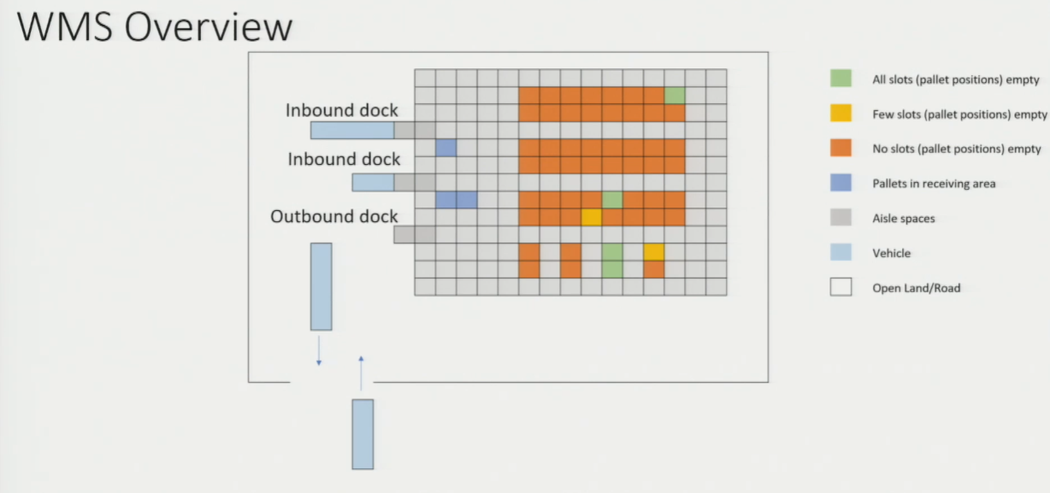
Core Warehouse Activity Sequence

1 | Receiving (Inbound) | Materials arrive at inbound docks. Items unloaded, scanned (T&T integration), GRN generated. Dock is checked for completion.
2 | Put Away | Items moved from inbound to designated storage location. WMS provides sequencing of put away to minimize travel. Location assigned based on SKU movement speed, size, etc.
3 | Storage | Items held in warehouse for planned duration. WMS shows real-time pallet position availability. Tracks utilization by zone, rack, position.
4 | Picking | Orders received → WMS generates pick list (sequence + quantity). Picker or automated equipment follows list. Picking order minimizes travel distance.
5 | Staging & Dispatch | Picked items moved to outbound area (staging). Loaded onto vehicle. GRN-equivalent for outbound generated. Dock allocated by TMS.

3. WMS — Key Functionalities
WMS Functionality | What it Does
Real-time Visualization | Shows top-view (and other views) of warehouse — which pallet positions are full, empty, partially empty  Color-coded by status: fully occupied, partially occupied, fully free  Gives instant snapshot of capacity utilization
Space Allocation / Slotting | Decision support: where to assign SKUs based on movement speed (fast-movers near outbound), size (large items at back), product type  Suggests optimal pallet position for each incoming product
Goods Receipt Management | Records inbound completion — all pallets unloaded? GRN generated? Integrated with T&T scanning  Links to ERP materials module
Put Away Sequencing | Tells picker/operator: visit position A first, then B — minimizes travel distance  Also handles multi-pallet put away sequencing
Pick List Generation | Based on orders received — generates ordered pick list with quantities and locations  Assigns pickers (personnel) and equipment to pick sequence  Minimizes travel; can handle partial picks and bulk picks
Performance Reporting | Daily productivity metrics: throughput, utilization %, equipment utilization, picker productivity  Zone-level utilization, facility-level throughput  Supports operations review and process improvement

★ WMS = real-time inventory visibility + activity sequencing + performance reporting. It tells you WHERE things are and WHAT to do next.

4. Transportation Management System (TMS)
What TMS Focuses On
- TMS manages the movement of materials between facilities — factory → warehouse → DC → retail store
- Covers: manpower, equipment, commercial terms, regulatory compliance, route planning
- Overlaps with ERP (vendor management, invoicing) and WMS (dock allocation) — integration is key
- Can be implemented for all SC movements or only specific segments (e.g., last-mile only)

TMS Key Terminology
- FTL — Full Truck Load: vehicle used to full capacity for one consignment
- LTL — Less than Truck Load: vehicle carries partial loads — may combine multiple consignments
- Backhaul: return journey of vehicle after delivery — goes to warehouse OR proceeds to another pickup
- Dock: loading/unloading bay at a warehouse — same term used in warehousing and port contexts
- Yard management: managing vehicle and equipment parking area around the warehouse building

TMS Functionalities

TMS Functionality | What it Does
Dock Scheduling | Which vehicle goes to which inbound/outbound dock? How many docks should operate today?  When will a dock be free? → Assign next vehicle. When should dispatch be scheduled by?  Connects TMS with WMS — dock availability depends on warehouse pick/load progress
Yard Management | Manages open space around the warehouse — parking of vehicles awaiting dock allocation  Positioning of heavy equipment (cranes, forklifts) awaiting call  Tracks what is in the yard and when it needs to move
Freight Management | Mode selection: road vs sea vs air — decision support based on cost, speed, urgency  FTL (Full Truck Load) vs LTL (Less than Truck Load) decisions — maximize vehicle utilization  Compares freight costs across options for a given route
Documentation | Auto-generates shipping documents, delivery orders, customs paperwork  Handles regulatory/compliance requirements for inter-state or international shipments  Reduces manual documentation work on a per-trip basis
Vehicle Routing | For last-mile / multi-stop deliveries: decides optimal order of retail stores to visit  Minimizes total distance / time for a given load  Also determines backhaul: should empty vehicle return to warehouse or proceed to another pick-up?

★ TMS = decision support for MOVEMENT. It answers: which mode, which route, which dock, which vehicle, and when. Eliminates manual route planning and documentation.

5. Integration — How ERP, WMS & TMS Connect
- All three systems are interrelated — data flows between them continuously:

Integration | Data Flow & Purpose
ERP ↔ WMS | Production schedule informs warehouse of expected inbound. Dispatch records update ERP materials module. Spend data flows to ERP finance.
ERP ↔ TMS | Vendor delivery schedules from ERP procurement module inform TMS dock scheduling. Freight costs flow back to ERP for spend analysis.
WMS ↔ TMS | WMS tells TMS when dock is clear and items are ready for loading. TMS tells WMS vehicle arrival time so dock can be pre-cleared.
WMS ↔ T&T | Barcode / RFID scans at inbound dock update WMS inventory in real time. Pick scan confirms what has been picked and loaded.
TMS ↔ T&T | Vehicle tracking (GPS, telematics) updates TMS with live vehicle location and delivery confirmation at customer point.

- Example end-to-end flow: production completes at factory (ERP) → truck dispatched (TMS) → arrives at dock (WMS dock scheduling) → items scanned in (T&T → WMS) → pick list generated for retail orders (WMS) → vehicle routed to stores (TMS)

6. Implementation Considerations for WMS & TMS
- Same principles as ERP — must evaluate need, cost-benefit, and fit before procuring:

Implementation Question | Why it Matters
Scale of business? | Determines which modules to implement and whether to procure or build in-house
ERP integration possible? | If WMS/TMS data cannot feed into ERP, value of the system is severely reduced — data must be reportable and accountable
Partner WMS/TMS fit? | Can your warehouse WMS talk to your vendor's or client's TMS? Cross-system compatibility is key for end-to-end visibility
Digital readiness of people? | Staff must be trained on devices, software, tools — not just operational tasks. Traditional shop-floor-only thinking is insufficient
Adaptability to change? | Product mix changes, demand variability, regulation changes (taxes, pricing) — can the WMS/TMS adapt without full redesign?
Routing complexity? | Complex multi-stop or multi-mode routing requirements determine how sophisticated a TMS module is needed
Scalability? | Ability to adapt quickly also determines how fast the business can scale. Rigid systems slow growth.

- India context: massive warehousing infrastructure development underway — WMS adoption accelerating. PM Gati Shakti initiative driving logistics digitization.
- Insight: shop floor warehouse staff must be digitally upskilled — purely operational training is no longer sufficient

Session Summary
- WMS: manages activities inside the warehouse — receiving, put away, storage, picking, dispatch, performance metrics
- TMS: manages material movement between facilities — dock scheduling, yard mgmt, freight, routing, documentation
- Key terms: dock, aisle, pallet position, SKU, FTL, LTL, backhaul, yard, cross-dock, sort center
- WMS functionalities: real-time visualization, slotting, GRN, put away sequencing, pick list, performance reporting
- TMS functionalities: dock scheduling, yard management, freight mode selection, documentation, vehicle routing
- Integration: ERP ↔ WMS ↔ TMS ↔ T&T — all linked. Data flows across all systems in a well-designed SC IS landscape
- WMS vs ERP: separate because warehouse activities are too specific and granular for generic ERP — same vendor possible but different modules
- Implementation: scale, ERP integration, partner compatibility, digital readiness, adaptability, routing complexity

★ Exam Tip: WMS ≠ ERP. ERP handles common business functions. WMS handles warehouse-specific activities. They integrate but are separate modules — often from the same or different vendors.
★ Exam Tip: 5 warehouse activities in order: Receiving → Put Away → Storage → Picking → Dispatch (staging). WMS provides decision support at every step.
★ Exam Tip: TMS key decisions: which dock, which mode (FTL/LTL/road/sea), which route (multi-stop retail delivery), backhaul plan. Each is automated via TMS rather than manual planning.
★ Exam Tip: Integration matters: WMS dock availability feeds TMS scheduling; TMS vehicle arrival feeds WMS dock prep. T&T scan data feeds WMS inventory. If any system is isolated, its value drops sharply.

